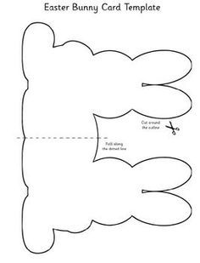<https://gr.pinterest.com/pin/842525042777622516/>

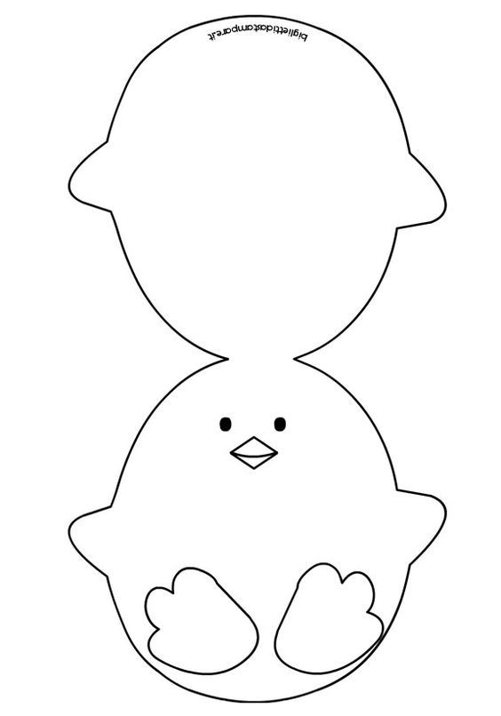<https://gr.pinterest.com/pin/675117800367459574/>

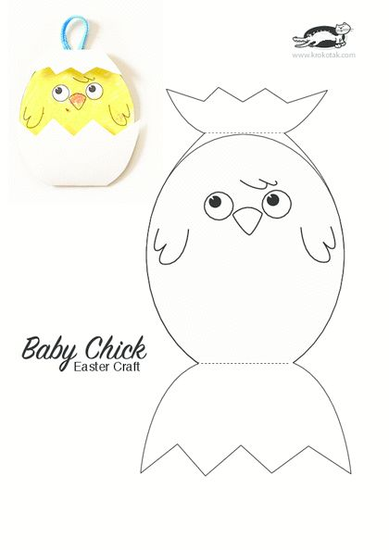<https://gr.pinterest.com/pin/323766660695597046/>

<https://gr.pinterest.com/pin/704813410413105969/>

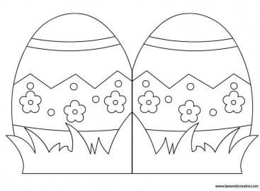

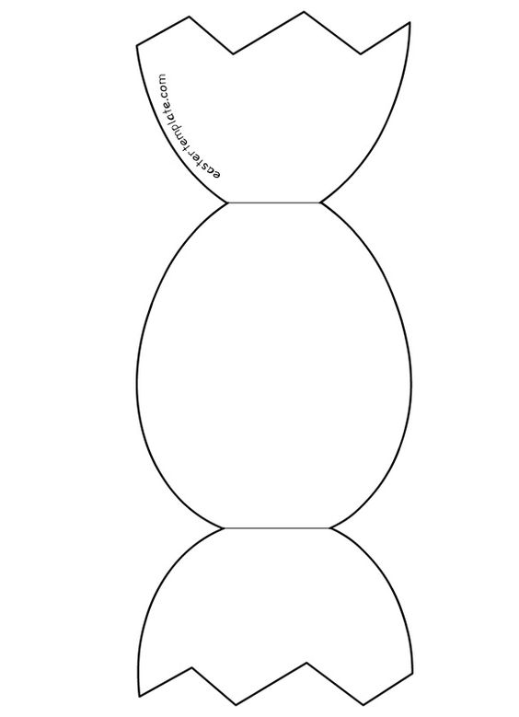<https://gr.pinterest.com/pin/553379872949647823/>

<https://gr.pinterest.com/pin/303781937368892370/>