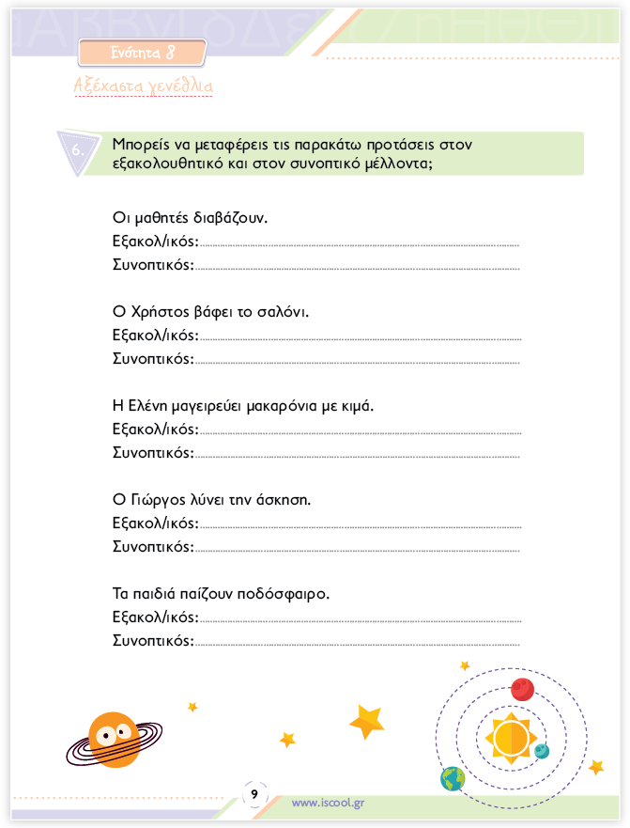

[https://www.iscool.gr/%CE%B3-](https://www.iscool.gr/%CE%B3-%CE%B4%CE%B7%CE%BC%CE%BF%CF%84%CE%B9%CE%BA%CE%BF%CF%85/%CE%B3%CE%BB%CF%89%CF%83%CF%83%CE%B1-%CE%B3-%CE%B4%CE%B7%CE%BC%CE%BF%CF%84%CE%B9%CE%BA%CE%BF%CF%85-%CF%84%CE%B5%CF%85%CF%87%CE%BF%CF%83-%CE%B2.htm)